FASE 1 – Nano, Iputils-ping, Python

Testing dell’iputils-ping

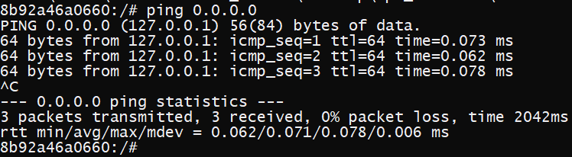

Testing di python3

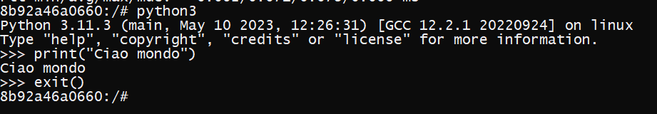

Testing di nano

